1. Clone a Table from another DB. E.g. Assume we have 2 DBs – DEV_DB and PRD_DB and the Roles for these DBs are DEV_ROLE and PRD_ROLE. The Roles should be exclusive to the DB which means DEV_ROLE should not be able to access the PROD_DB and vice versa. Now Clone a Table from PRD_DB to DEV_DB.

USE ROLE ACCOUNTADMIN;

-- CREATING DBs

CREATE DATABASE DEV_DB;

CREATE DATABASE PRD_DB;

USE PRD_DB;

-- CREATING TABLE in PRD_DB

CREATE OR REPLACE TABLE PRD_DB.PUBLIC.members(

id number(8) NOT NULL,

name varchar(255) default NULL,

fee number(3) NULL

);

-- INSERTING VALUES INSIDE THE Table

INSERT INTO PRD_DB.PUBLIC.members (id,name,fee)

VALUES

(1,'Joe',0),

(2,'Jane',0),

(3,'George',0),

(4,'Betty',0),

(5,'Sally',0);

--CLONING THE TABLE to PRD_DB

CREATE OR REPLACE Transient TABLE DEV_DB.PUBLIC.members

CLONE PRD_DB.PUBLIC.members;

SELECT * FROM DEV_DB.PUBLIC.members;

CREATE OR REPLACE ROLE DEV_ROLE;

-- Granting access to the Role

GRANT USAGE ON DATABASE DEV_DB TO ROLE DEV_ROLE;

GRANT ALL ON ALL SCHEMAS IN DATABASE DEV_DB TO ROLE DEV_ROLE;

GRANT ALL ON ALL TABLES IN DATABASE DEV_DB TO ROLE DEV_ROLE;

GRANT USAGE ON WAREHOUSE COMPUTE_WH TO ROLE DEV_ROLE;

GRANT ROLE DEV_ROLE TO USER MELWINMPK;

USE ROLE DEV_ROLE;

SELECT * FROM DEV_DB.PUBLIC.members;

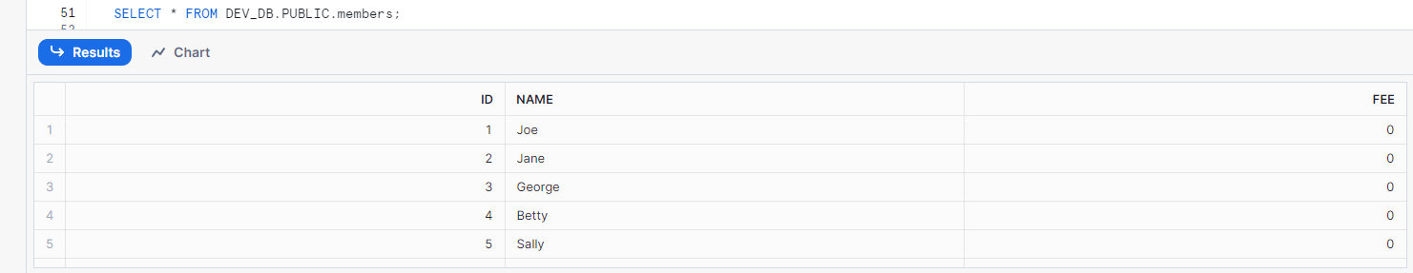

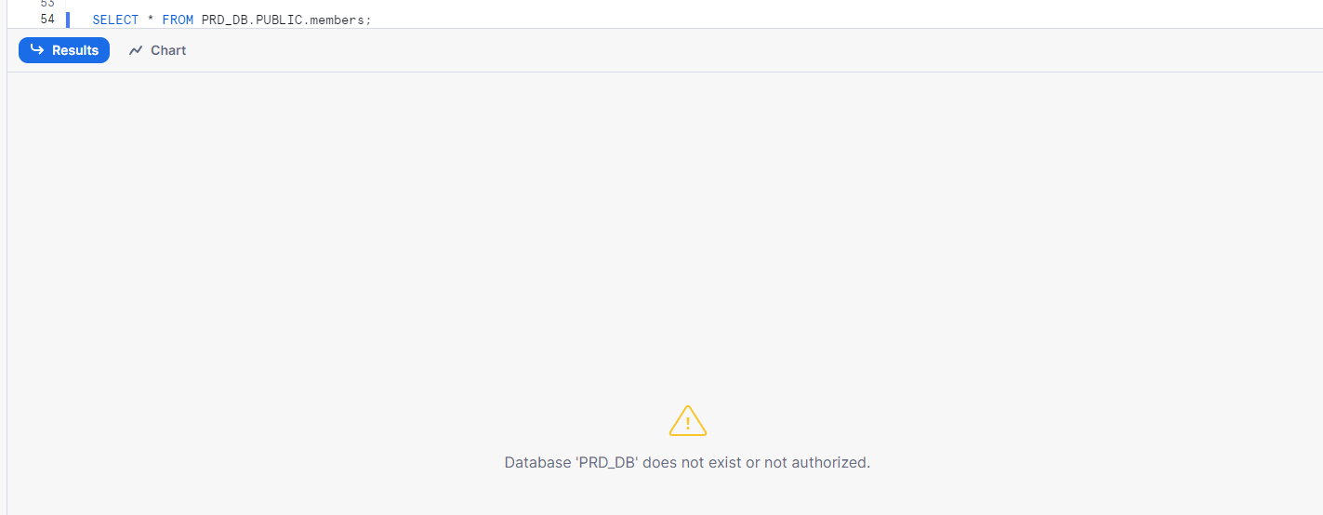

2. Create a Temporary Table, Insert some data, do some Updates/Delete on the data and restore the Original data using Time Travel.

USE DEV_DB;

-- Create a temporary table

CREATE Temporary TABLE DEV_DB.PUBLIC.temp_table AS

SELECT * FROM DEV_DB.PUBLIC.members;

INSERT INTO DEV_DB.PUBLIC.temp_table (id,name,fee)

VALUES

(6,'Alvin',0),

(7,'John',0);

SELECT CURRENT_TIMESTAMP(); -- 2024-05-28 01:04:51.259 -0700

UPDATE DEV_DB.PUBLIC.temp_table

SET fee = 9

WHERE id IN (6,7) ;

SELECT * FROM DEV_DB.PUBLIC.temp_table;

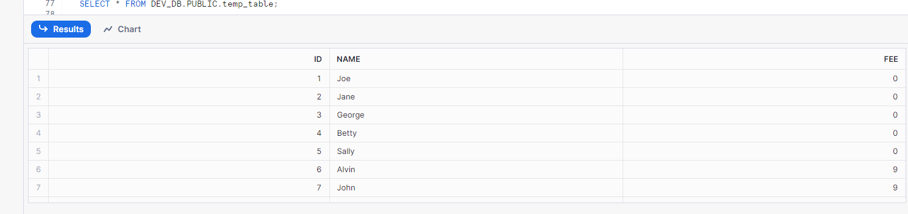

ALTER SESSION SET TIMEZONE = 'UTC';

-- Restore original data using Time Travel

SELECT *

FROM DEV_DB.PUBLIC.temp_table

AT (TIMESTAMP => TO_TIMESTAMP('2024-05-28 01:04:51.259'));

-- Specify the timestamp before any changes

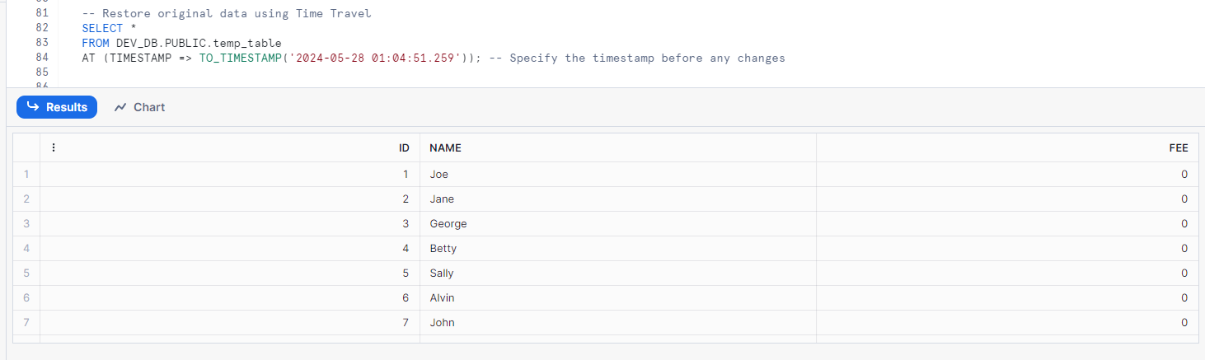

3. Create a Transient Table, Insert some data, do some Updates/Delete on the data and restore the Original data using Time Travel.

-- Create a transient table

CREATE TRANSIENT TABLE DEV_DB.PUBLIC.my_transient_table AS

SELECT * FROM DEV_DB.PUBLIC.members;

-- Insert data into the transient table

INSERT INTO DEV_DB.PUBLIC.my_transient_table (id,name,fee)

VALUES

(6,'Alvin',0),

(7,'John',0);

SELECT CURRENT_TIMESTAMP(); -- 2024-05-28 08:53:10.012 +0000

-- Perform updates and deletes

UPDATE DEV_DB.PUBLIC.my_transient_table

SET fee = 9

WHERE id IN (6,7) ;

SELECT CURRENT_TIMESTAMP(); -- 2024-05-28 08:54:06.127 +0000

SELECT *

FROM DEV_DB.PUBLIC.my_transient_table;

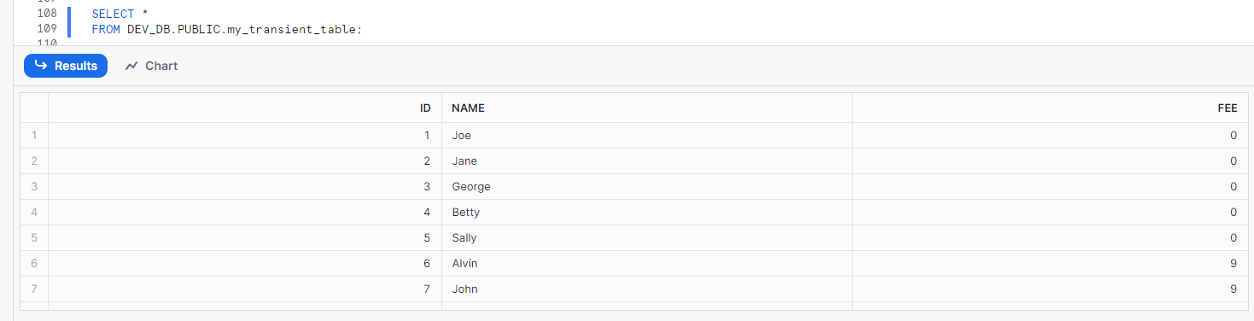

-- Restore original data using Time Travel

SELECT *

FROM DEV_DB.PUBLIC.my_transient_table

AT (TIMESTAMP => '2024-05-28 08:53:10.012 +0000'::timestamp);

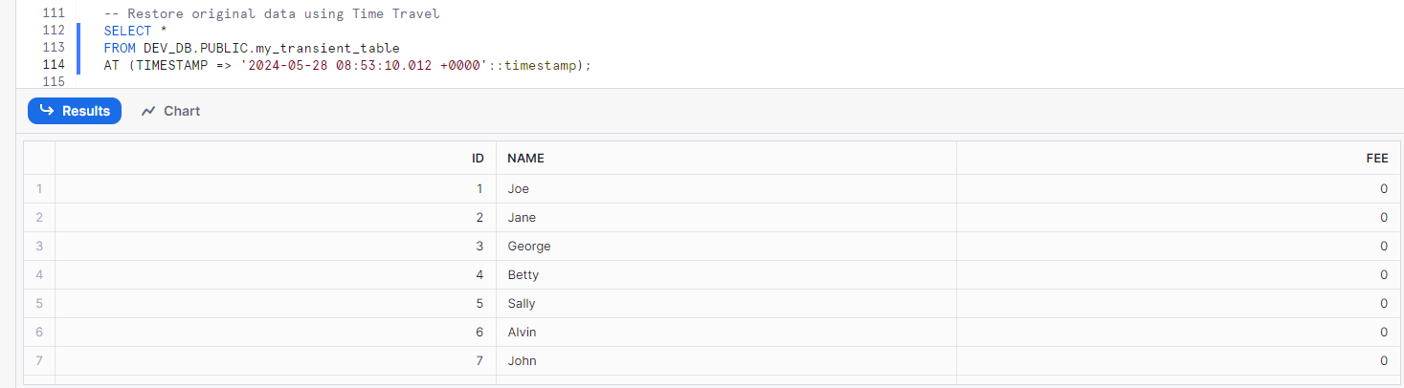

4. Create a normal (Permanent) Table, set the Time Travel Interval to 1 day, drop the Table and restore it using the FailSafe option.

-- Create a permanent table

CREATE TABLE DEV_DB.PUBLIC.my_permanent_table (

id INT,

name STRING

);

INSERT INTO DEV_DB.PUBLIC.my_permanent_table (id, name) VALUES (1,'Tom'),(2,'Bob'),(2,'Alice');

-- Set the Time Travel interval to 1 day (default)

-- For Standard Endtions there is Only 1 Day od Time travel

-- For Enterprice Editions up to 90 days of timetravel

-- DATA_RETENTION_TIME_IN_DAYS = 1

-- alter Table my_permanent_table set DATA_RETENTION_TIME_IN_DAYS=1;

-- Drop the table (simulate accidental deletion)

DROP TABLE my_permanent_table;

5. Create a Table (TABLE1) and load data from multiple sources on hourly basis for 4 - 5 hours. On the 5th hour restore the data to how it was at the end of 1st hour. Clone the TABLE1 to TABLE2 based on how the data was at the end of 2nd hour.

6. Create a stream on Table to log the changes and capture the change logs in a separate Table.

-- Create a table to store the names and fees paid by members of a gym

CREATE OR REPLACE TABLE DEV_DB.PUBLIC.members (

id number(8) NOT NULL,

name varchar(255) default NULL,

fee number(3) NULL

);

CREATE SCHEMA DEV_DB.STREAMS;

-- Create a stream to track changes to date in the MEMBERS table

CREATE OR REPLACE STREAM DEV_DB.STREAMS.member_check ON TABLE DEV_DB.PUBLIC.members;

INSERT INTO members (id,name,fee)

VALUES

(1,'Joe',0),

(2,'Jane',0),

(3,'George',0),

(4,'Betty',0),

(5,'Sally',0);

-- The stream records the inserted rows

SELECT * FROM DEV_DB.STREAMS.member_check;

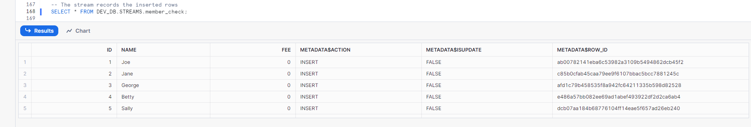

7. Create an External Table and auto refresh the data using Snowpipe.

CREATE OR REPLACE STORAGE INTEGRATION ACCESS_TO_S3BUCKET

TYPE=EXTERNAL_STAGE

STORAGE_PROVIDER='S3'

STORAGE_AWS_ROLE_ARN='arn:aws:iam::533267410818:role/S3_read_access_for_snowflake'

ENABLED=TRUE

STORAGE_ALLOWED_LOCATIONS=('s3://lz-snowflake/Snowflake/Employees/');

DESCRIBE STORAGE INTEGRATION ACCESS_TO_S3BUCKET;

-- CREATE EXTERNAL STAGE

CREATE OR REPLACE STAGE DEV_DB.PUBLIC.employees_stage

url='s3://lz-snowflake/Snowflake/Employees/'

file_format = (type = 'CSV' field_delimiter = ',' field_optionally_enclosed_by = '"' skip_header = 1)

STORAGE_INTEGRATION = ACCESS_TO_S3BUCKET;

DROP TABLE DEV_DB.PUBLIC.employees;

CREATE OR REPLACE TABLE DEV_DB.PUBLIC.employees_snowpipe (

id INT,

first_name STRING,

last_name STRING,

email STRING,

location STRING,

department STRING

);

SELECT COUNT(*) FROM DEV_DB.PUBLIC.employees_snowpipe;

COPY INTO DEV_DB.PUBLIC.employees_snowpipe FROM @DEV_DB.PUBLIC.employees_stage;

LIST @DEV_DB.PUBLIC.employees_stage;

CREATE SCHEMA DEV_DB.PIPES;

// Define pipe

CREATE OR REPLACE pipe DEV_DB.PIPES.employee_pipe

auto_ingest = TRUE

AS

COPY INTO DEV_DB.PUBLIC.employees_snowpipe FROM @DEV_DB.PUBLIC.employees_stage;

DESCRIBE pipe DEV_DB.PIPES.employee_pipe;

-- getting the notification Channel to set up the S3 bucket Notification

-- arn:aws:sqs:us-east-1:851725646910:sf-snowpipe-AIDA4MTWN7Q7DAHEQB3QX-vadq_r2TdV9BEEYU0QRPIA

SELECT COUNT(*) FROM DEV_DB.PUBLIC.employees_snowpipe;

Before uploading the Data to S3 bucket  
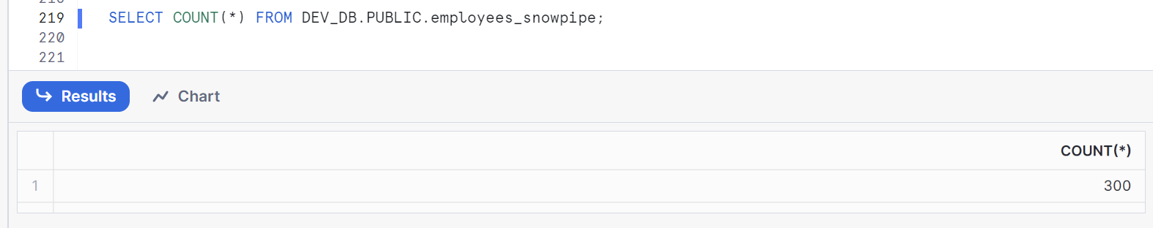  
After Uploading the Data   
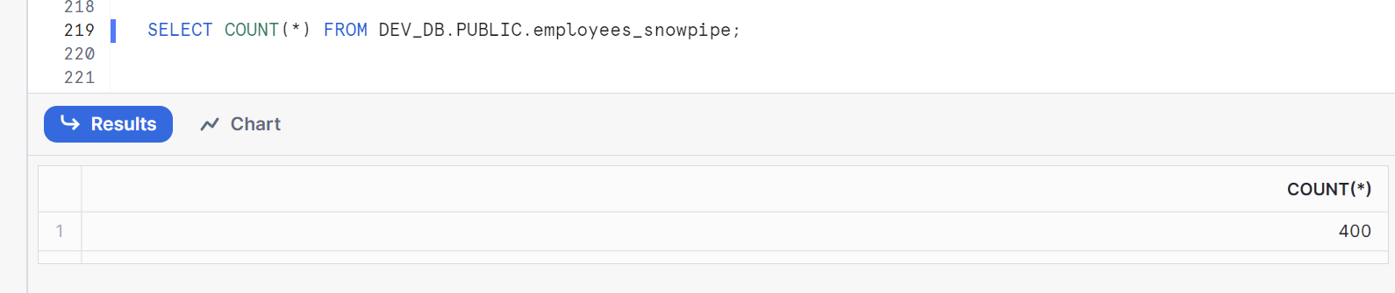

8. Create an External Table and instead of using Snowpipe, use a Stored Procedure and Task to refresh the data.

CREATE OR REPLACE STORAGE INTEGRATION ACCESS_TO_S3BUCKET

TYPE=EXTERNAL_STAGE

STORAGE_PROVIDER='S3'

STORAGE_AWS_ROLE_ARN='arn:aws:iam::533267410818:role/S3_read_access_for_snowflake'

ENABLED=TRUE

STORAGE_ALLOWED_LOCATIONS=('s3://lz-snowflake/Snowflake/Employees/');

DESCRIBE STORAGE INTEGRATION ACCESS_TO_S3BUCKET;

-- CREATE EXTERNAL STAGE

CREATE OR REPLACE STAGE DEV_DB.PUBLIC.employees_stage

url='s3://lz-snowflake/Snowflake/Employees/'

file_format = (type = 'CSV' field_delimiter = ',' field_optionally_enclosed_by = '"' skip_header = 1)

STORAGE_INTEGRATION = ACCESS_TO_S3BUCKET;

SELECT COUNT(*) FROM DEV_DB.PUBLIC.employees;

DROP STAGE DEV_DB.PUBLIC.employees_stage;

CREATE OR REPLACE EXTERNAL TABLE DEV_DB.PUBLIC.employees (

id INT AS (value:c1::INTEGER),

first_name STRING AS (value:c2::TEXT),

last_name STRING AS (value:c3::TEXT),

email STRING AS (value:c4::TEXT),

location STRING AS (value:c5::TEXT),

department STRING AS (value:c6::TEXT)

)

WITH LOCATION = @DEV_DB.PUBLIC.employees_stage

FILE_FORMAT = (TYPE = CSV field_delimiter = ',' field_optionally_enclosed_by = '"' SKIP_HEADER = 1);

LIST @DEV_DB.PUBLIC.employees_stage;

CREATE OR REPLACE PROCEDURE DEV_DB.PUBLIC.EMPLOYEES_DATA_PROCEDURE ()

RETURNS STRING NOT NULL

LANGUAGE SQL

AS

$$

ALTER EXTERNAL TABLE DEV_DB.PUBLIC.employees REFRESH;

$$;

CREATE OR REPLACE TASK DEV_DB.PUBLIC.EMPLOYEES_DATA_TASK_PROCEDURE_CALL

WAREHOUSE = COMPUTE_WH

SCHEDULE = 'USING CRON * * * * * UTC'

AS CALL DEV_DB.PUBLIC.EMPLOYEES_DATA_PROCEDURE();

ALTER TASK DEV_DB.PUBLIC.EMPLOYEES_DATA_TASK_PROCEDURE_CALL resume;

LIST @DEV_DB.PUBLIC.employees_stage;

SELECT COUNT(*) FROM DEV_DB.PUBLIC.employees;

Before running with the task

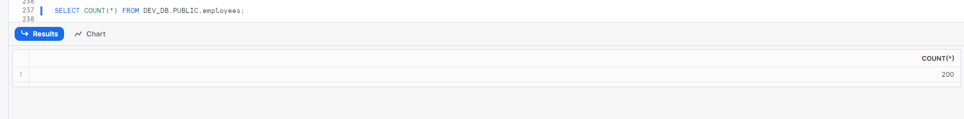

After Creating the Task   
  
After Uploading the Data to S3 bucket   
after a minutes

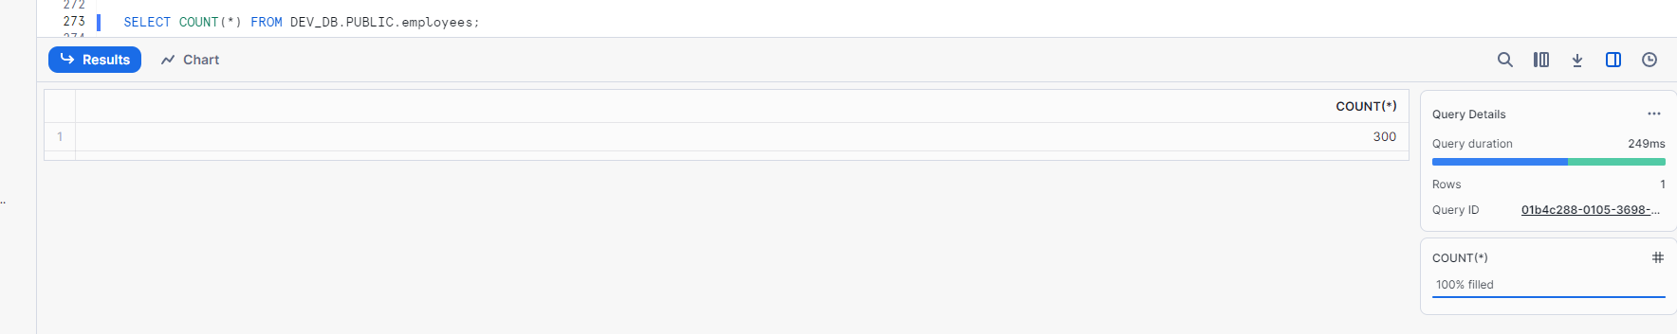

9. Create a Masking policy to mask PII data on an External Table.

GRANT USAGE ON DATABASE DEV_DB TO ROLE ANALYST_MASKED;

GRANT ALL ON ALL SCHEMAS IN DATABASE DEV_DB TO ROLE ANALYST_MASKED;

GRANT ALL ON ALL TABLES IN DATABASE DEV_DB TO ROLE ANALYST_MASKED;

GRANT USAGE ON DATABASE DEV_DB TO ROLE ANALYST_FULL;

GRANT ALL ON ALL SCHEMAS IN DATABASE DEV_DB TO ROLE ANALYST_FULL;

GRANT ALL ON ALL TABLES IN DATABASE DEV_DB TO ROLE ANALYST_FULL;

-- grant warehouse access to roles

GRANT USAGE ON WAREHOUSE COMPUTE_WH TO ROLE ANALYST_MASKED;

GRANT USAGE ON WAREHOUSE COMPUTE_WH TO ROLE ANALYST_FULL;

-- assign roles to a user

GRANT ROLE ANALYST_MASKED TO USER MELWINMPK;

GRANT ROLE ANALYST_FULL TO USER MELWINMPK;

-- Set up masking policy

create or replace masking policy PII

as (val varchar) returns varchar ->

case

when current_role() in ('ANALYST_FULL', 'ACCOUNTADMIN') then val

else '##-###-##'

end;

-- Apply policy on a specific column

ALTER TABLE IF EXISTS DEV_DB.PUBLIC.employees MODIFY COLUMN email

SET MASKING POLICY PII;

-- Validating policies

USE ROLE ANALYST_FULL;

SELECT * FROM DEV_DB.PUBLIC.employees;

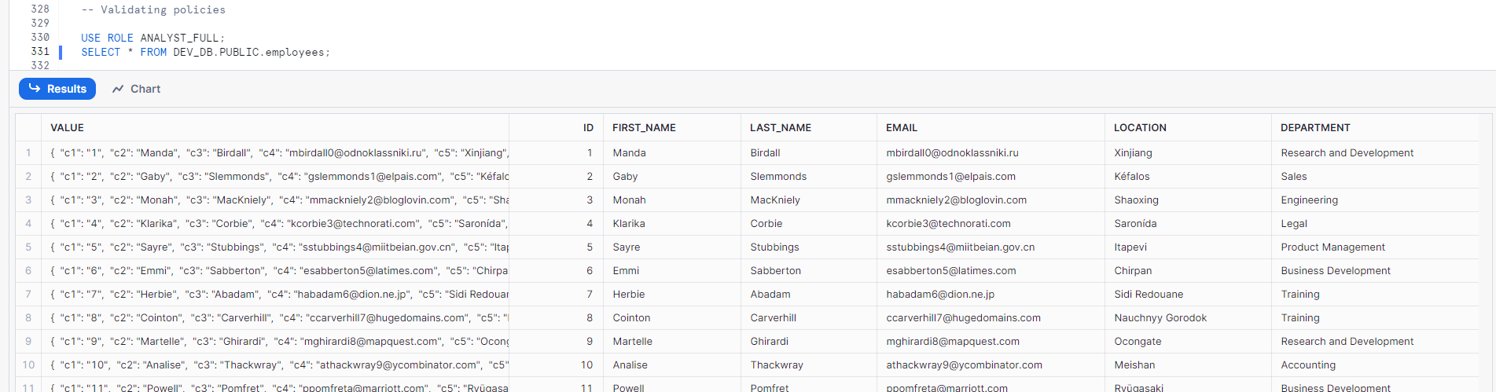

USE ROLE ANALYST_MASKED;

SELECT * FROM DEV_DB.PUBLIC.employees;

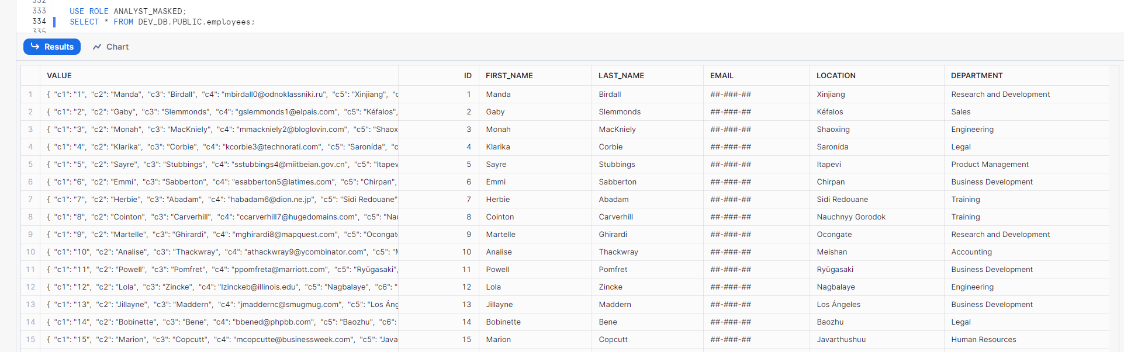

10. Create a Secure view to restrict data based on current Role.

-- Secure view

CREATE secure view prd_db.Public.secure_dest as

select * from SNOWFLAKE_SAMPLE_DATA.TPCH_SF1.CUSTOMER limit 100;

USE ROLE DEV_ROLE;

SELECT * FROM prd_db.Public.secure_dest limit 10;

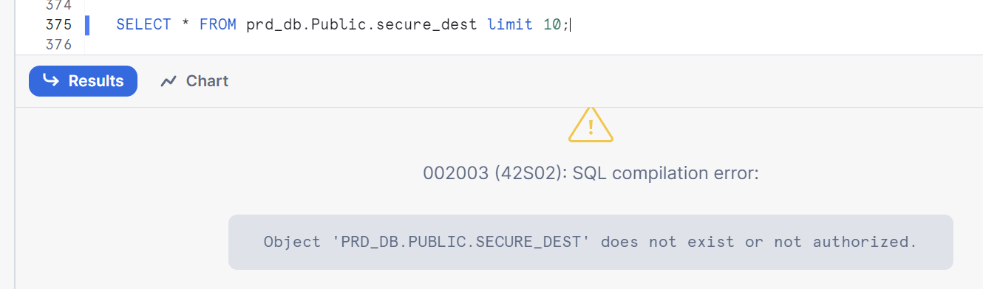

11. Create a Materialized view.

-- CREATE OR REPLACE MATERIALIZED VIEW

SELECT * FROM employees;

CREATE OR REPLACE MATERIALIZED VIEW employee_summery as

SELECT DEPARTMENT, count(*) as cnt FROM employees

GROUP BY DEPARTMENT;

SELECT * FROM employee_summery;

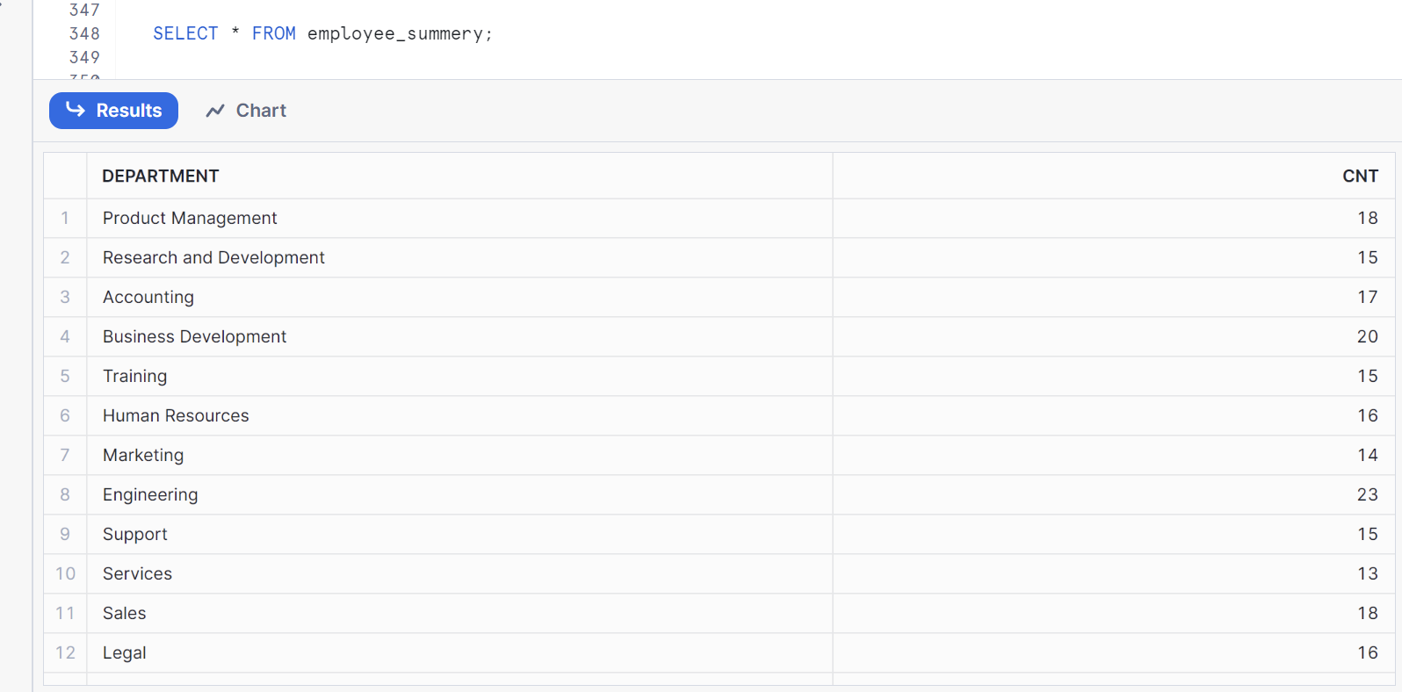

12. Create a Role and provide ReadOnly privileges to PROD_DB.

-- Granting access to the Role

GRANT USAGE ON DATABASE PRD_DB TO ROLE DEV_ROLE;

GRANT ALL ON ALL SCHEMAS IN DATABASE PRD_DB TO ROLE DEV_ROLE;

GRANT SELECT ON ALL TABLES IN DATABASE PRD_DB TO ROLE DEV_ROLE;

USE ROLE DEV_ROLE;

SELECT * FROM PRD_DB.PUBLIC.MEMBERS;  
  
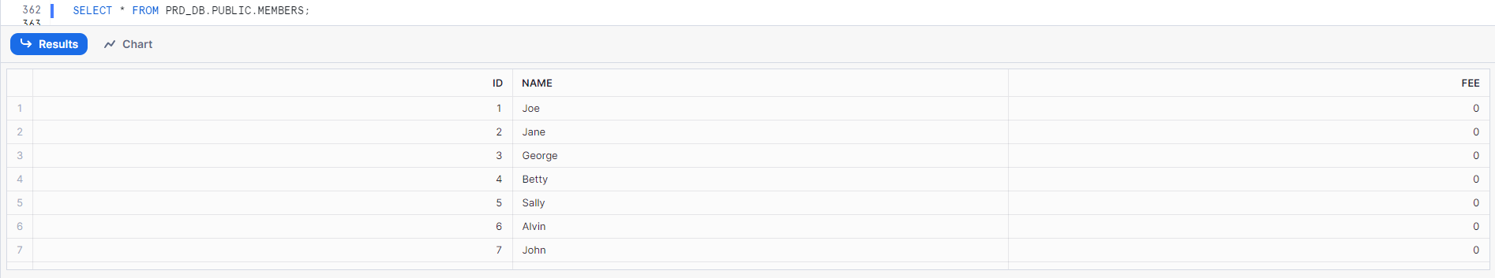

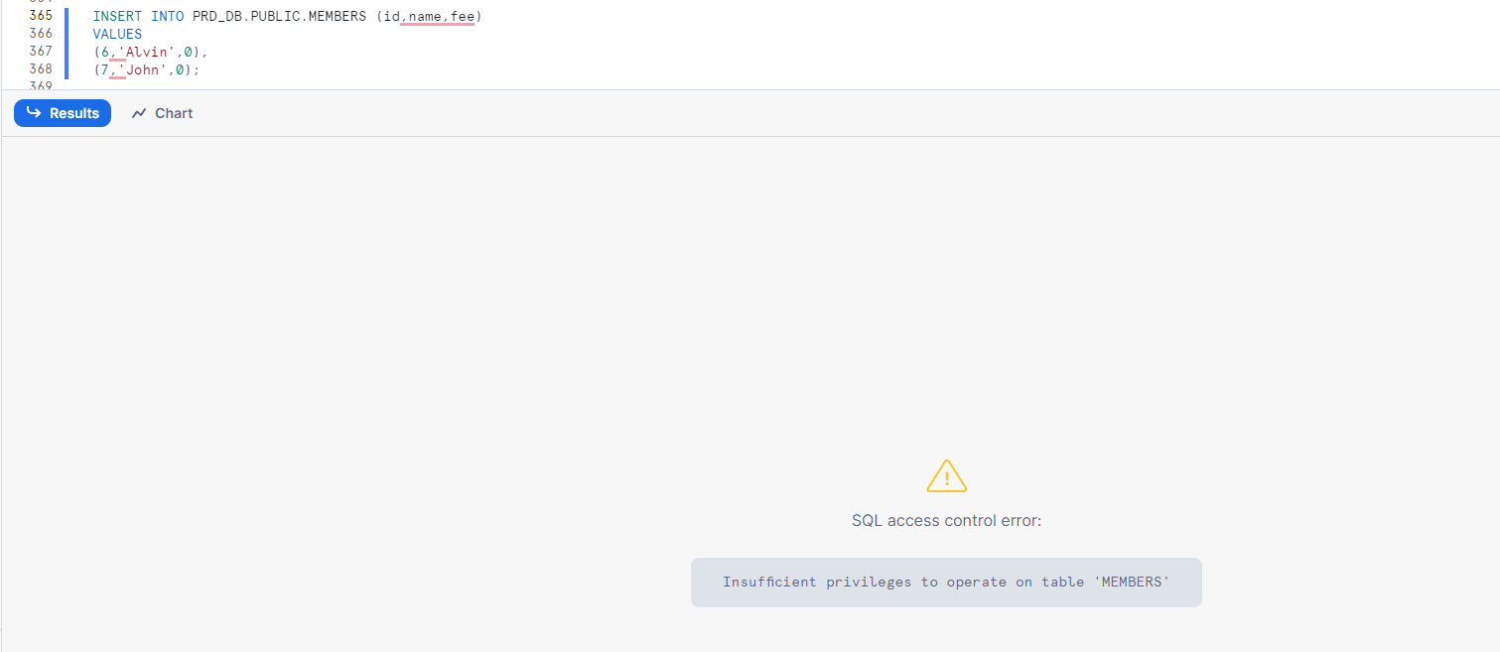

13. Resource Monitor: Create a Resource Monitor to be triggered on consumption of 90 Snowflake credits and assign it to a Warehouse.

CREATE OR REPLACE RESOURCE MONITOR credit_monitor WITH CREDIT_QUOTA=90

TRIGGERS ON 100 PERCENT DO SUSPEND;

ALTER WAREHOUSE FIRST_WAREHOUSE SET RESOURCE_MONITOR = credit_monitor;

14. Identify the WH COST and Storage costs associated with your Snowflake Account.

15. Create an Internal and External Stage, load data from S3 to these stages and Insert the data into a Table.

-- Create INTERNAL Stage

CREATE OR REPLACE STAGE DEV_DB.PUBLIC.amazone_books_stage

FILE_FORMAT = (TYPE= csv FIELD_DELIMITER = ',' FIELD_OPTIONALLY_ENCLOSED_BY = '"', SKIP_HEADER=1);

CREATE OR REPLACE TABLE DEV_DB.PUBLIC.amazone_books (

BOOK_ID NUMBER(38,0) NOT NULL,

BOOK_TITLE VARCHAR(16777216),

BOOK_AMOUNT FLOAT,

BOOK_AUTHOR VARCHAR(16777216),

BOOK_RATING FLOAT,

BOOK_LINK VARCHAR(16777216),

BUSINESS_DATE DATE

);

-- load the Data using the python connector snowflake.connector

SELECT $1,$2,$3,$4,$5,$6,$7 FROM @DEV_DB.PUBLIC.amazone_books_stage;

LIST @DEV_DB.PUBLIC.amazone_books_stage;

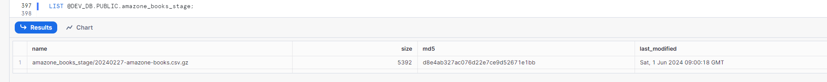

COPY INTO DEV_DB.PUBLIC.amazone_books FROM @DEV_DB.PUBLIC.amazone_books_stage;

SELECT * FROM DEV_DB.PUBLIC.amazone_books;

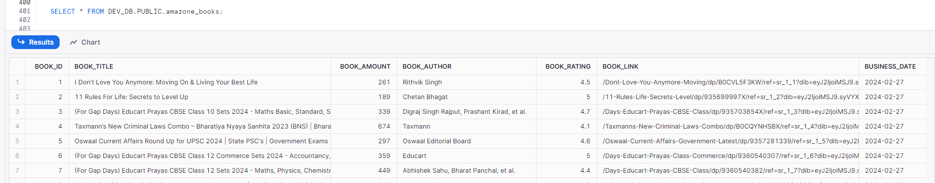

-- Create external Stage

CREATE OR REPLACE STORAGE INTEGRATION ACCESS_TO_S3BUCKET_AWS

TYPE=EXTERNAL_STAGE

STORAGE_PROVIDER='S3'

STORAGE_AWS_ROLE_ARN='arn:aws:iam::533267410818:role/S3_read_access_for_snowflake'

ENABLED=TRUE

STORAGE_ALLOWED_LOCATIONS=('s3://lz-snowflake/Snowflake/');

CREATE OR REPLACE STAGE DEV_DB.PUBLIC.amazone_books_ext_stage

url='s3://lz-snowflake/Snowflake/amazonebooks_external/amazone_books/'

file_format = (type = 'CSV' field_delimiter = ',' field_optionally_enclosed_by = '"' skip_header = 1)

STORAGE_INTEGRATION = ACCESS_TO_S3BUCKET_AWS;

-- CREATE EXTERNAL TABLE

CREATE OR REPLACE EXTERNAL TABLE DEV_DB.PUBLIC.AMAZONE_BOOKS_EXT(

BOOK_ID NUMBER(38, 0) AS (value:c1::INTEGER)

,BOOK_TITLE VARCHAR(16777216) AS (value:c2::TEXT)

,BOOK_AMOUNT FLOAT AS (value:c3::FLOAT)

,BOOK_AUTHOR VARCHAR(16777216) AS (value:c4::TEXT)

,BOOK_RATING FLOAT AS (value:c5::float)

,BOOK_LINK VARCHAR(16777216) AS (value:c6::TEXT)

,BUSINESS_DATE DATE AS TO_DATE(value:c7::VARCHAR,'YYYY-MM-DD')

,FILE_DATE_PARTITION NUMBER(10,0) as (split_part(METADATA$FILENAME,'/',4)::int)

)

PARTITION BY (FILE_DATE_PARTITION)

WITH LOCATION = @amazone_books_ext_stage

FILE_FORMAT = (TYPE = CSV field_delimiter = ',' field_optionally_enclosed_by = '"' SKIP_HEADER = 1);

-- ALTER EXTERNAL TABLE IF EXISTS DEV_DB.PUBLIC.amazone_books_ext_stage ADD FILES ('20240227/20240227-amazone-books.csv');

SELECT * FROM DEV_DB.PUBLIC.AMAZONE_BOOKS_EXT;

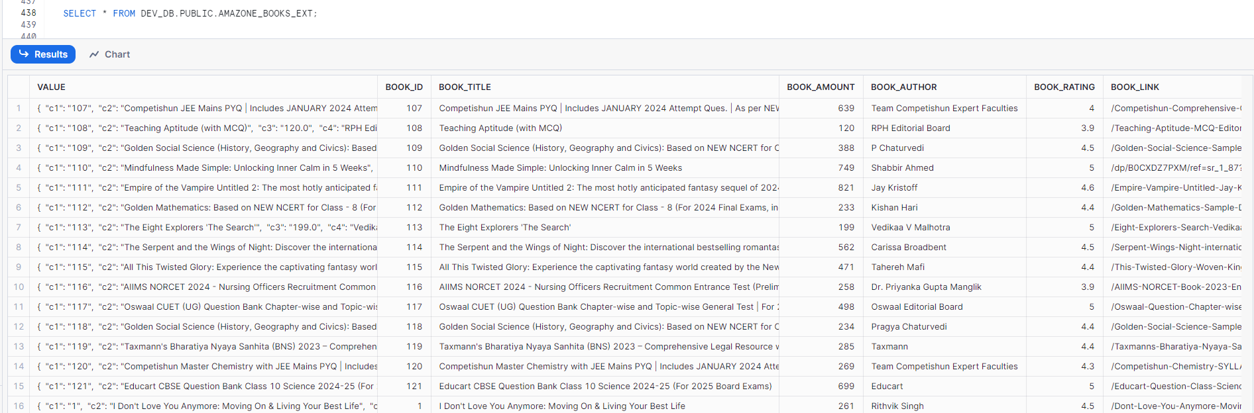

16. Create a stored procedure, switch role inside the stored and drop a Table.

E.g. Assume Stored Procedure SP1 is executed using ROLE1, Switch to ROLE2 inside the Stored Procedure and drop a Table using ROLE2.

CREATE OR REPLACE PROCEDURE DEV_DB.PUBLIC.DROP_TABLE()

RETURNS STRING NOT NULL

LANGUAGE SQL

EXECUTE AS OWNER

AS

$$

DROP TABLE DEV_DB.PUBLIC.members;

$$;

GRANT ALL ON ALL PROCEDURES IN DATABASE DEV_DB TO ROLE DEV_ROLE;

USE ROLE DEV_ROLE;

CALL DEV_DB.PUBLIC.DROP_TABLE();

SELECT * FROM DEV_DB.PUBLIC.members;

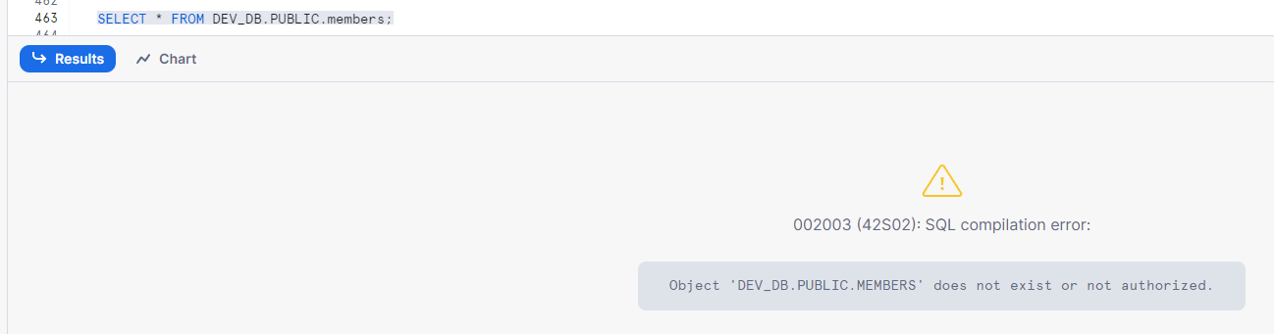

17. Identify the Queries executed on DEV_DB and which User\Role has executed most Queries.

SELECT

QUERY_TEXT

FROM

SNOWFLAKE.ACCOUNT_USAGE.QUERY_HISTORY

WHERE DATABASE_NAME = 'DEV_DB' limit 10;

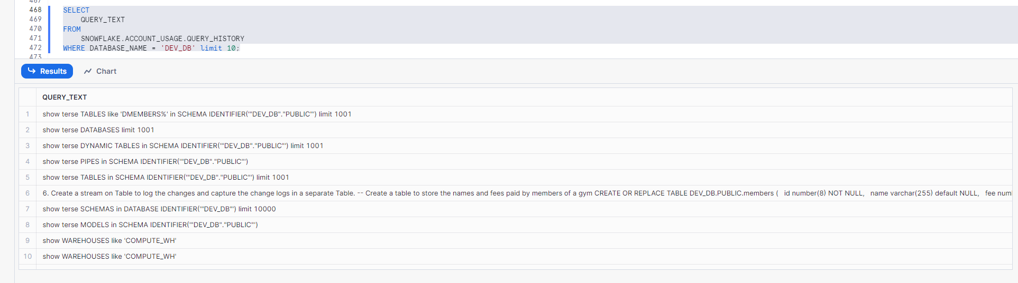

SELECT

USER_NAME, ROLE_NAME, COUNT(*) as Count

FROM

SNOWFLAKE.ACCOUNT_USAGE.QUERY_HISTORY

WHERE DATABASE_NAME = 'DEV_DB'

GROUP BY USER_NAME, ROLE_NAME

ORDER BY COUNT(*) desc;

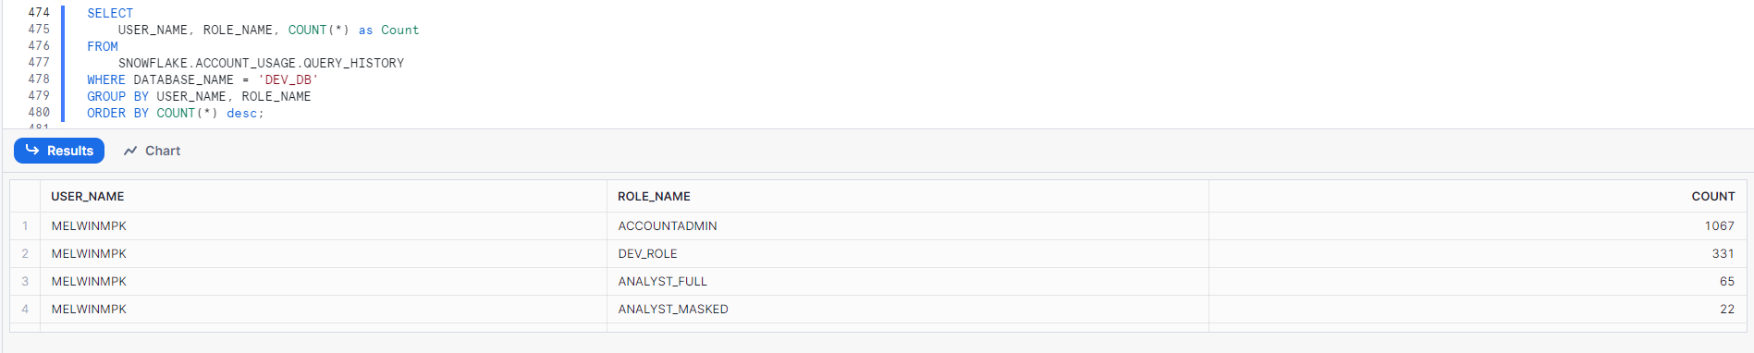

18. Identify if there any cross-environment access (DEV_ROLE granted Privilege to PRD_DB and vice versa)

SELECT *

FROM snowflake.account_usage.grants_to_roles

WHERE GRANTEE_NAME='DEV_ROLE'

AND TABLE_CATALOG='PRD_DB';

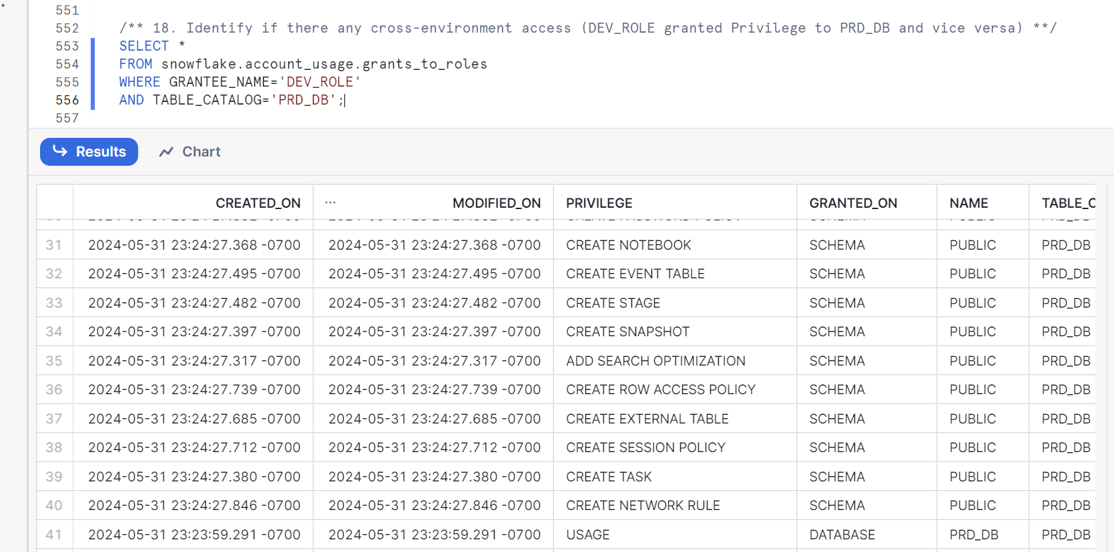

SELECT *

FROM snowflake.account_usage.grants_to_roles

WHERE GRANTEE_NAME='PRD_ROLE'

AND TABLE_CATALOG='DEV_DB';

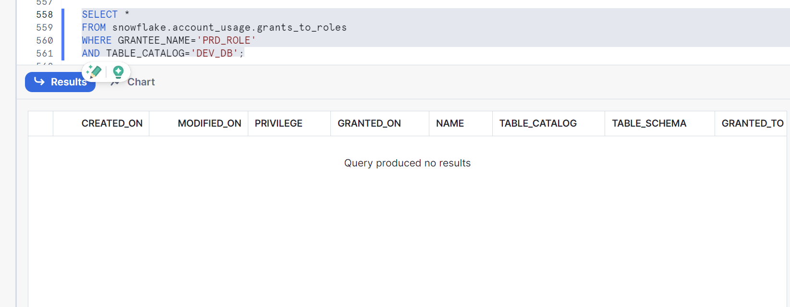

19. Set up Future Grants on DEV_DB so that once a Table is created, Select Privilege is provided to DEV_ROLE2.

CREATE OR REPLACE ROLE DEV_ROLE2;

-- Granting access to the Role

GRANT USAGE ON DATABASE DEV_DB TO ROLE DEV_ROLE2;

GRANT ALL ON ALL SCHEMAS IN DATABASE DEV_DB TO ROLE DEV_ROLE2;

GRANT ALL ON ALL TABLES IN DATABASE DEV_DB TO ROLE DEV_ROLE2;

GRANT ALL ON FUTURE TABLES IN DATABASE DEV_DB TO ROLE DEV_ROLE2;

20. Create a Task that’s executed on daily basis at 9.30 AM IST.

CREATE OR REPLACE TASK DEV_DB.PUBLIC.my_daily_task

WAREHOUSE = COMPUTE_WH

SCHEDULE = 'USING CRON 30 9 * * * Asia/Kolkata'

AS

-- Your SQL statements or stored procedure here

-- For example:

SELECT DEV_DB.PUBLIC.amazone_books;

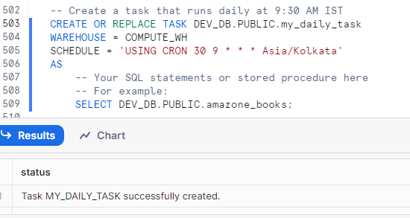

21. Create a Schema with Managed Access and Grant access to Objects within the schema using a role other than SYSADMIN & Schema’s Owner.

22. Retrieve data from a previously executed Query using Result_scan function.

SELECT * FROM TABLE(RESULT_SCAN(LAST_QUERY_ID(-1)));

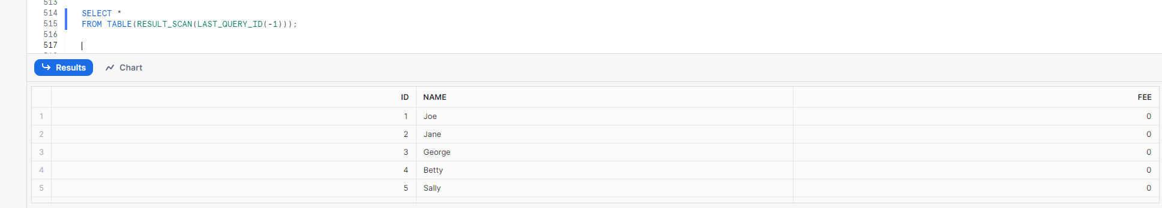

23. Create a Share and provide access to specific Tables in the schema to the share.

CREATE SHARE my_share;

GRANT usage on database dev_db TO SHARE my_share;

GRANT usage on schema dev_db.public TO SHARE my_share;

GRANT SELECT ON TABLE public.destination_table TO SHARE my_share;

GRANT SELECT ON TABLE public.emp_tb TO SHARE my_share;

24. Create a Share and share the entire schema (all Tables, Views, etc.) to the share.

CREATE SHARE my_schema_share;

GRANT USAGE ON DATABASE DEV_DB TO SHARE my_schema_share;

GRANT USAGE ON SCHEMA DEV_DB.PUBLIC TO SHARE my_schema_share;

GRANT SELECT, INSERT, UPDATE, DELETE ON ALL TABLES IN SCHEMA DEV_DB.PUBLIC TO SHARE my_schema_share;

GRANT USAGE ON ALL SEQUENCES IN SCHEMA DEV_DB.PUBLIC TO SHARE my_schema_share;

GRANT USAGE ON ALL STREAMS IN SCHEMA DEV_DB.PUBLIC TO SHARE my_schema_share;

GRANT USAGE ON ALL TASKS IN SCHEMA DEV_DB.PUBLIC TO SHARE my_schema_share;

GRANT USAGE ON ALL VIEWS IN SCHEMA DEV_DB.PUBLIC TO SHARE my_schema_share;

GRANT USAGE ON ALL MATERIALIZED VIEWS IN SCHEMA DEV_DB.PUBLIC TO SHARE my_schema_share;

25. Clone a Schema with External Tables.

CREATE OR REPLACE SCHEMA DEV_DB.CLONED_PUBLIC

CLONE DEV_DB.PUBLIC;

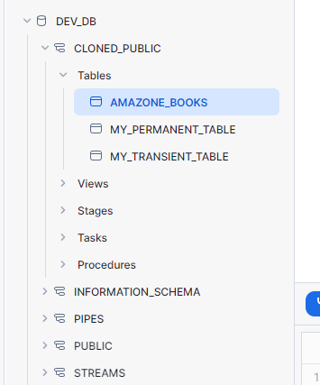

SELECT * FROM DEV_DB.CLONED_PUBLIC.AMAZONE_BOOKS limit 10;

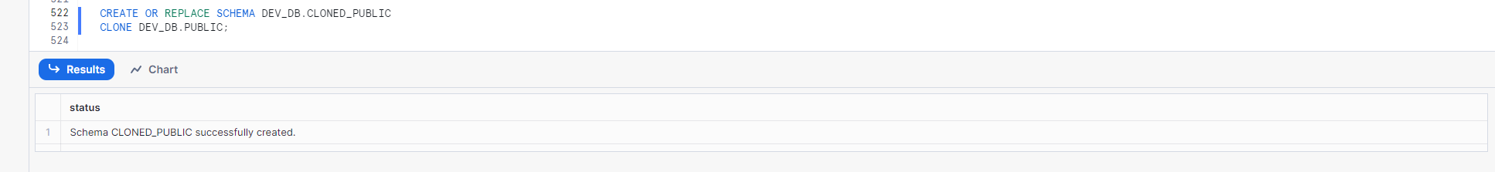

-- External table cannot be cloned

-- we need to recreate it from the stage (as the respective stage is cloned)

-- CREATE EXTERNAL TABLE

CREATE OR REPLACE EXTERNAL TABLE DEV_DB.CLONED_PUBLIC.AMAZONE_BOOKS_EXT(

BOOK_ID NUMBER(38, 0) AS (value:c1::INTEGER)

,BOOK_TITLE VARCHAR(16777216) AS (value:c2::TEXT)

,BOOK_AMOUNT FLOAT AS (value:c3::FLOAT)

,BOOK_AUTHOR VARCHAR(16777216) AS (value:c4::TEXT)

,BOOK_RATING FLOAT AS (value:c5::float)

,BOOK_LINK VARCHAR(16777216) AS (value:c6::TEXT)

,BUSINESS_DATE DATE AS TO_DATE(value:c7::VARCHAR,'YYYY-MM-DD')

,FILE_DATE_PARTITION NUMBER(10,0) as (split_part(METADATA$FILENAME,'/',4)::int)

)

PARTITION BY (FILE_DATE_PARTITION)

WITH LOCATION = @DEV_DB.CLONED_PUBLIC.amazone_books_ext_stage

FILE_FORMAT = (TYPE = CSV field_delimiter = ',' field_optionally_enclosed_by = '"' SKIP_HEADER = 1);

SELECT * FROM DEV_DB.CLONED_PUBLIC.AMAZONE_BOOKS_EXT limit 10;

